Tutorial 3 Deep learning with medical imaging
This is a high-level introduction into practical machine learning for medical image classification. The goal of this tutorial is to build a deep learning classifier to accurately differentiate between chest and abdominal X-rays. The model is trained using 75 images de-identified images obtained from Open-i.
MD.ai is used to dispaly the DICOM images, and to create the image-level annotations. We then use the MD.ai python client library to download the images+annotations and prepare the datasets, which are then used to train the classification model.
- Original public github repo is based on: https://github.com/ImagingInformatics/machine-learning
- MD.ai annotator project URL: https://public.md.ai/annotator/project/PVq9raBJ
- MD.ai python client libray URL: https://github.com/mdai/mdai-client-py
- MD.ai documentation URL: https://docs.md.ai

Setup environment
# Import packages
%%bash
pip install -q -U mdai
# Import the mdai library
import mdai
mdai.__version__
# Create an `mdai` client
mdai_client = mdai.Client(domain='public.md.ai', access_token="")

p = mdai_client.project('PVq9raBJ', path='./lesson1-data')
p.show_label_groups()
# this maps label ids to class ids as a dict obj
labels_dict = {
'L_38Y7Jl': 0, # Abdomen
'L_z8xEkB': 1, # Chest
}

print(labels_dict)
p.set_labels_dict(labels_dict)

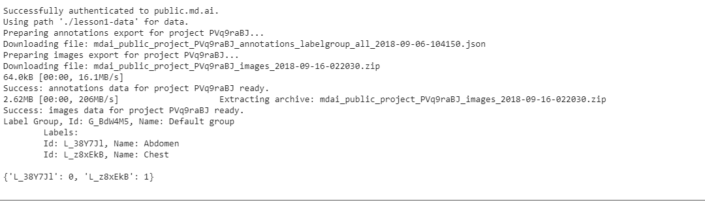

Preprocessing Data
### Create the *Training* and *Validation* datasets

#%%

p.show_datasets()

#%%

# create training dataset
train_dataset = p.get_dataset_by_name('TRAIN')
train_dataset.prepare()
train_image_ids = train_dataset.get_image_ids()
print(len(train_image_ids))

# create the validation dataset
val_dataset = p.get_dataset_by_name('VAL')
val_dataset.prepare()
val_image_ids = val_dataset.get_image_ids()
print(len(val_image_ids))

#%% md

### Display a few images

#%%

# visualize a few train images
mdai.visualize.display_images(train_image_ids[:2], cols=2)
mdai.visualize.display_images(val_image_ids[:2], cols=2)

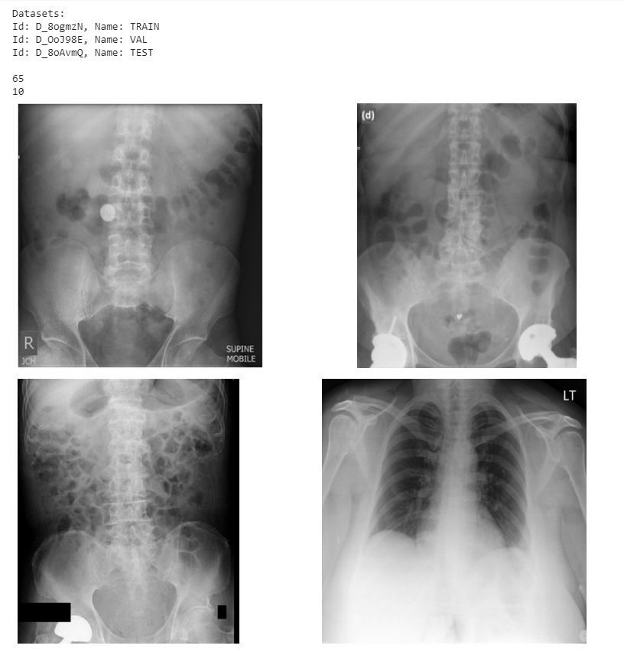

Training with network 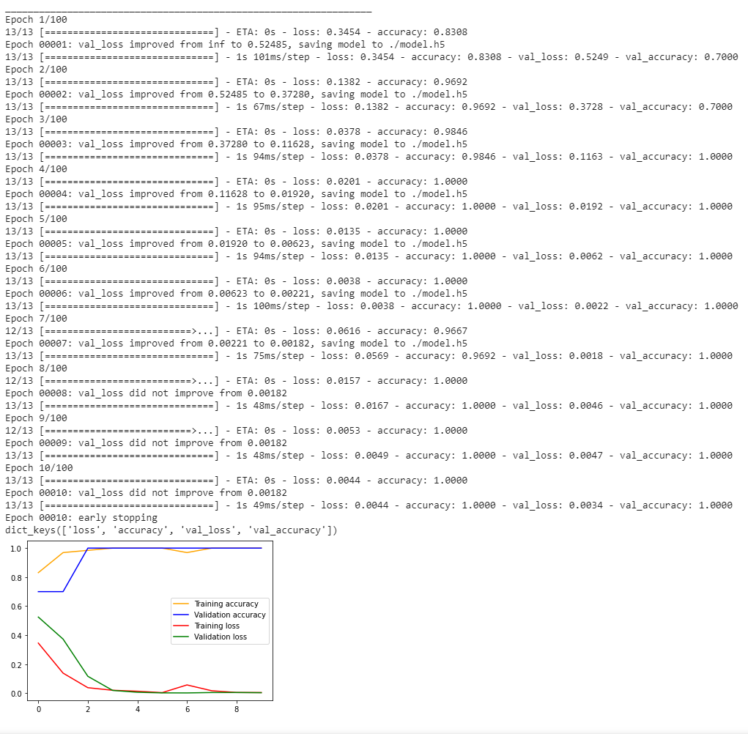
### Use tf.keras for training and validation

On Colab run the following %tensorflow_version line magic function to set tensorflow to v2.

#%%

%tensorflow_version 2.x

#%%

import tensorflow as tf

print(tf.__version__)
tf.keras.backend.clear_session()

#%%

# Define model parameters
img_width = 224
img_height = 224
epochs = 100

params = {
'dim': (img_width, img_height),
'batch_size': 5,
'n_classes': 2,
'n_channels': 3,
'shuffle': True,
}

#%%

base_model = tf.keras.applications.MobileNet(weights='imagenet', include_top=False,
input_shape=(img_width, img_height, 3))

output = tf.keras.layers.GlobalAveragePooling2D()(base_model.output)
output = tf.keras.layers.Dense(2, activation='softmax')(output)

model = tf.keras.Model(inputs=base_model.input, outputs=output)

model.compile(optimizer=tf.keras.optimizers.Adam(lr=0.0001),
loss='categorical_crossentropy', metrics=['accuracy'])

model.summary()

#%%

from mdai.visualize import load_dicom_image
import numpy as np
from PIL import Image

class DataGenerator(tf.keras.utils.Sequence):
def __init__(
self,
dataset,
batch_size=32,
dim=(32, 32),
n_channels=1,
n_classes=10,
shuffle=True,
to_RGB=True,
rescale=False,
):
"""Generates data for Keras fit_generator() function.
"""

# Initialization
self.dim = dim
self.batch_size = batch_size

self.img_ids = dataset.image_ids
self.imgs_anns_dict = dataset.imgs_anns_dict
self.dataset = dataset

self.n_channels = n_channels
self.n_classes = n_classes
self.shuffle = shuffle
self.to_RGB = to_RGB
self.rescale = rescale
self.on_epoch_end()

def __len__(self):
"Denotes the number of batches per epoch"
return int(np.floor(len(self.img_ids) / self.batch_size))

def __getitem__(self, index):
"Generate one batch of data"

# Generate indexes of the batch
indexes = self.indexes[index * self.batch_size : (index + 1) * self.batch_size]

# Find list of IDs
img_ids_temp = [self.img_ids[k] for k in indexes]

# Generate data
X, y = self.__data_generation(img_ids_temp)

return X, y

def on_epoch_end(self):
"Updates indexes after each epoch"
self.indexes = np.arange(len(self.img_ids))
if self.shuffle:
np.random.shuffle(self.indexes)

def __data_generation(self, img_ids_temp):
"Generates data containing batch_size samples"

# Initialization
X = np.empty((self.batch_size, *self.dim, self.n_channels))
y = np.empty((self.batch_size), dtype=int)

# Generate data
for i, ID in enumerate(img_ids_temp):
image = load_dicom_image(ID, to_RGB=self.to_RGB, rescale=self.rescale)
try:
image = Image.fromarray(image)
except Exception:
print(
"Pil.Image can't read image. Possible 12 or 16 bit image. Try rescale=True to "
+ "scale to 8 bit."
)

image = image.resize((self.dim[0], self.dim[1]))

X[i,] = image

ann = self.imgs_anns_dict[ID][0]
y[i] = self.dataset.classes_dict[ann["labelId"]]["class_id"]
return X, tf.keras.utils.to_categorical(y, num_classes=self.n_classes)

#%%

train_generator = DataGenerator(train_dataset, **params)
val_generator = DataGenerator(val_dataset, **params)

#%%

# Set callback functions to early stop training and save the best model so far
callbacks = [
tf.keras.callbacks.EarlyStopping(monitor='val_loss', patience=4, verbose=2, min_delta=1e-3),
tf.keras.callbacks.ModelCheckpoint(filepath='./model.h5', monitor='val_loss',
save_best_only=True, verbose=2)
]

history = model.fit(
train_generator,
epochs=epochs,
verbose=1,
callbacks=callbacks,
validation_data=val_generator,
)

#%%

import matplotlib.pyplot as plt

print(history.history.keys())

plt.figure()
plt.plot(history.history['accuracy'], 'orange', label='Training accuracy')
plt.plot(history.history['val_accuracy'], 'blue', label='Validation accuracy')
plt.plot(history.history['loss'], 'red', label='Training loss')
plt.plot(history.history['val_loss'], 'green', label='Validation loss')
plt.legend()
plt.show()

Sample output

Setup

Preprocessing Data

Training with Network

Testing Predictions

### Use tf.keras for training and validation

# On Colab run the following %tensorflow_version line magic function to set tensorflow to v2.

#%%
%tensorflow_version 2.x

#%%

import tensorflow as tf

print(tf.__version__)
tf.keras.backend.clear_session()

#%%

# Define model parameters
img_width = 224
img_height = 224
epochs = 100

params = {
'dim': (img_width, img_height),
'batch_size': 5,
'n_classes': 2,
'n_channels': 3,
'shuffle': True,
}
base_model = tf.keras.applications.MobileNet(weights='imagenet', include_top=False,
input_shape=(img_width, img_height, 3))

output = tf.keras.layers.GlobalAveragePooling2D()(base_model.output)
output = tf.keras.layers.Dense(2, activation='softmax')(output)

model = tf.keras.Model(inputs=base_model.input, outputs=output)

model.compile(optimizer=tf.keras.optimizers.Adam(lr=0.0001),
loss='categorical_crossentropy', metrics=['accuracy'])

model.summary()

#%%

from mdai.visualize import load_dicom_image
import numpy as np
from PIL import Image

class DataGenerator(tf.keras.utils.Sequence):
def __init__(
self,
dataset,
batch_size=32,
dim=(32, 32),
n_channels=1,
n_classes=10,
shuffle=True,
to_RGB=True,
rescale=False,
):
"""Generates data for Keras fit_generator() function.
"""

# Initialization
self.dim = dim
self.batch_size = batch_size

self.img_ids = dataset.image_ids
self.imgs_anns_dict = dataset.imgs_anns_dict
self.dataset = dataset

self.n_channels = n_channels
self.n_classes = n_classes
self.shuffle = shuffle
self.to_RGB = to_RGB
self.rescale = rescale
self.on_epoch_end()

def __len__(self):
"Denotes the number of batches per epoch"
return int(np.floor(len(self.img_ids) / self.batch_size))

def __getitem__(self, index):
"Generate one batch of data"

# Generate indexes of the batch
indexes = self.indexes[index * self.batch_size : (index + 1) * self.batch_size]

# Find list of IDs
img_ids_temp = [self.img_ids[k] for k in indexes]

# Generate data
X, y = self.__data_generation(img_ids_temp)

return X, y

def on_epoch_end(self):
"Updates indexes after each epoch"
self.indexes = np.arange(len(self.img_ids))
if self.shuffle:
np.random.shuffle(self.indexes)

def __data_generation(self, img_ids_temp):
"Generates data containing batch_size samples"

# Initialization
X = np.empty((self.batch_size, *self.dim, self.n_channels))
y = np.empty((self.batch_size), dtype=int)

# Generate data
for i, ID in enumerate(img_ids_temp):
image = load_dicom_image(ID, to_RGB=self.to_RGB, rescale=self.rescale)
try:
image = Image.fromarray(image)
except Exception:
print(
"Pil.Image can't read image. Possible 12 or 16 bit image. Try rescale=True to "
+ "scale to 8 bit."
)

image = image.resize((self.dim[0], self.dim[1]))

X[i,] = image

ann = self.imgs_anns_dict[ID][0]
y[i] = self.dataset.classes_dict[ann["labelId"]]["class_id"]
return X, tf.keras.utils.to_categorical(y, num_classes=self.n_classes)

#%%

train_generator = DataGenerator(train_dataset, **params)
val_generator = DataGenerator(val_dataset, **params)

#%%

# Set callback functions to early stop training and save the best model so far
callbacks = [
tf.keras.callbacks.EarlyStopping(monitor='val_loss', patience=4, verbose=2, min_delta=1e-3),
tf.keras.callbacks.ModelCheckpoint(filepath='./model.h5', monitor='val_loss',
save_best_only=True, verbose=2)
]

history = model.fit(
train_generator,
epochs=epochs,
verbose=1,
callbacks=callbacks,
validation_data=val_generator,
)

#%%

import matplotlib.pyplot as plt

print(history.history.keys())

plt.figure()
plt.plot(history.history['accuracy'], 'orange', label='Training accuracy')
plt.plot(history.history['val_accuracy'], 'blue', label='Validation accuracy')
plt.plot(history.history['loss'], 'red', label='Training loss')
plt.plot(history.history['val_loss'], 'green', label='Validation loss')
plt.legend()
plt.show()

